Practical 5: Create Google Form – Attendance Report

Aim

To design a Google Form and analyze responses.

Objectives
• To create form with multiple question types
• To collect sample responses
• To analyze responses

Materials Required
• Google account
• Internet

Procedure
Create new Google Form
Open Google Forms from your Google account and click “Blank Form” to start a new form.
This opens an empty form where you can add questions.
Title it “Student Attendance Report”
Enter the title at the top of the form and add a short description if needed.
This helps respondents understand the purpose of the form.
Add MCQs, rating, checkbox and short answer
Use the question type menu to insert multiple-choice questions, rating scales, checkboxes, and short-answer fields.
Arrange the questions in a logical order for easy response.
Customize theme
Click the Theme icon to change colors, fonts, and header images.
This improves the appearance and makes the form visually appealing.
Share form and collect responses
Use the Send button to share the form via link, email, or QR code.
Allow participants to submit their responses through any device.
View summary charts
Go to the Responses tab to see automatic charts and graphs generated by Google Forms.
These visual summaries help you quickly analyze the collected data.
Take screenshots
Capture screenshots of the form, responses, and charts for documentation.
Save them for use in reports or practical records.

Google form:
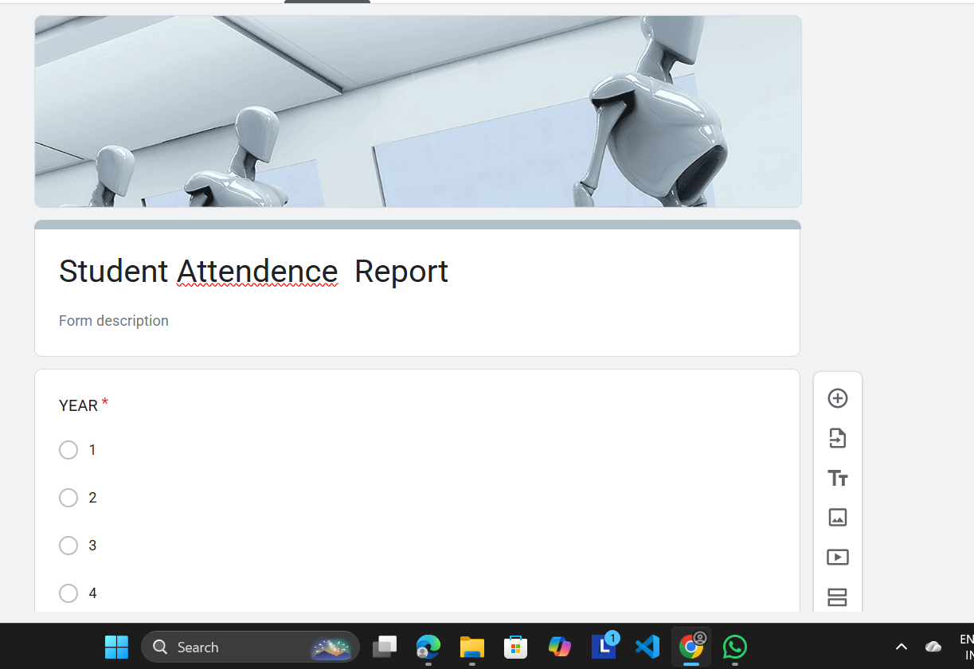

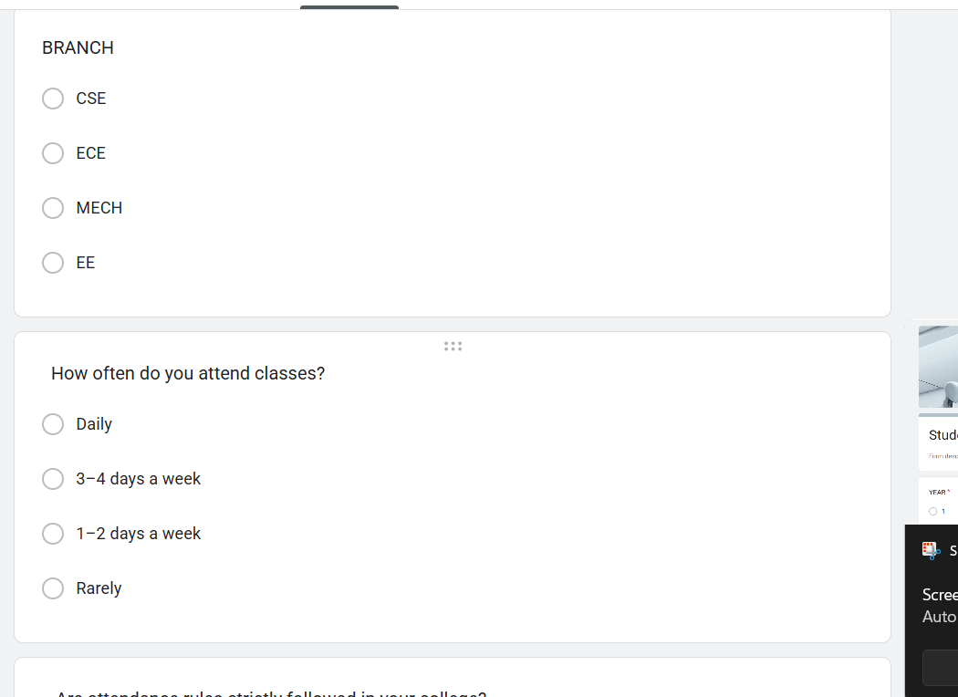
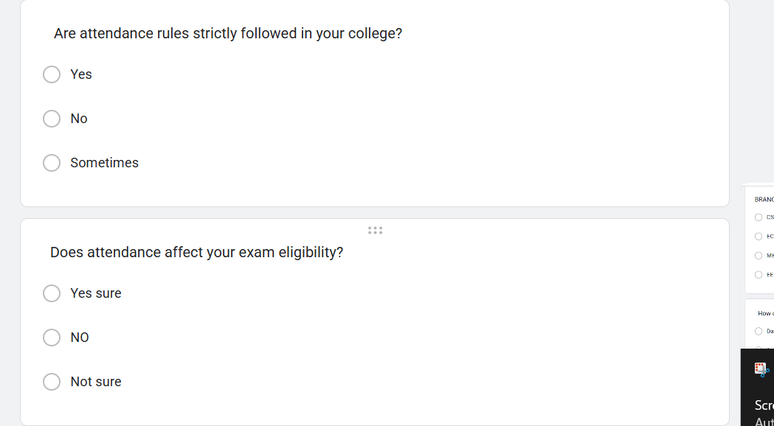

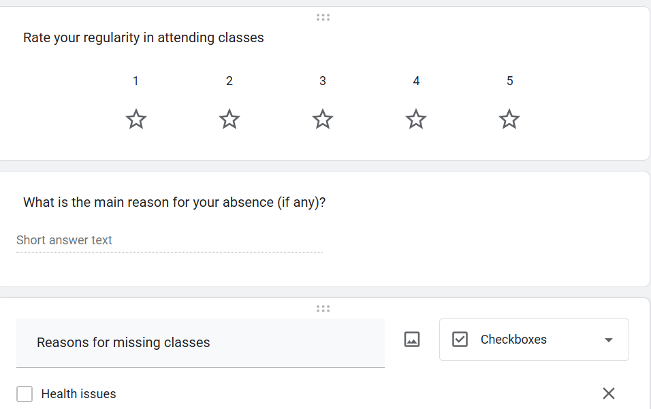

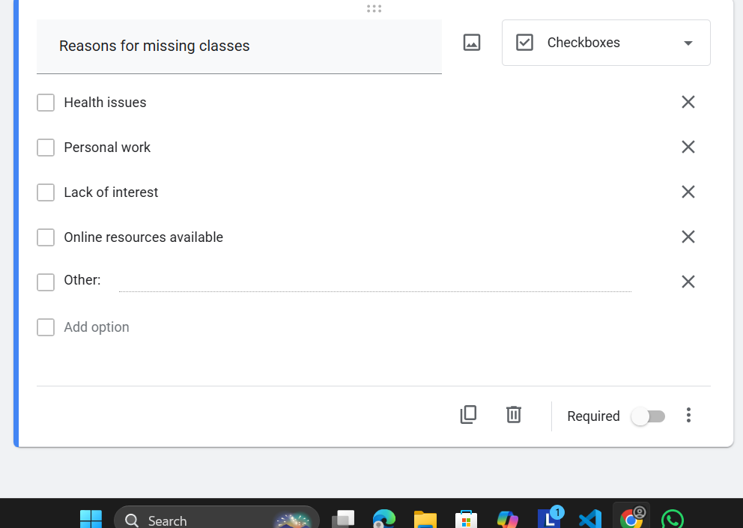

RESPONSE:

1)

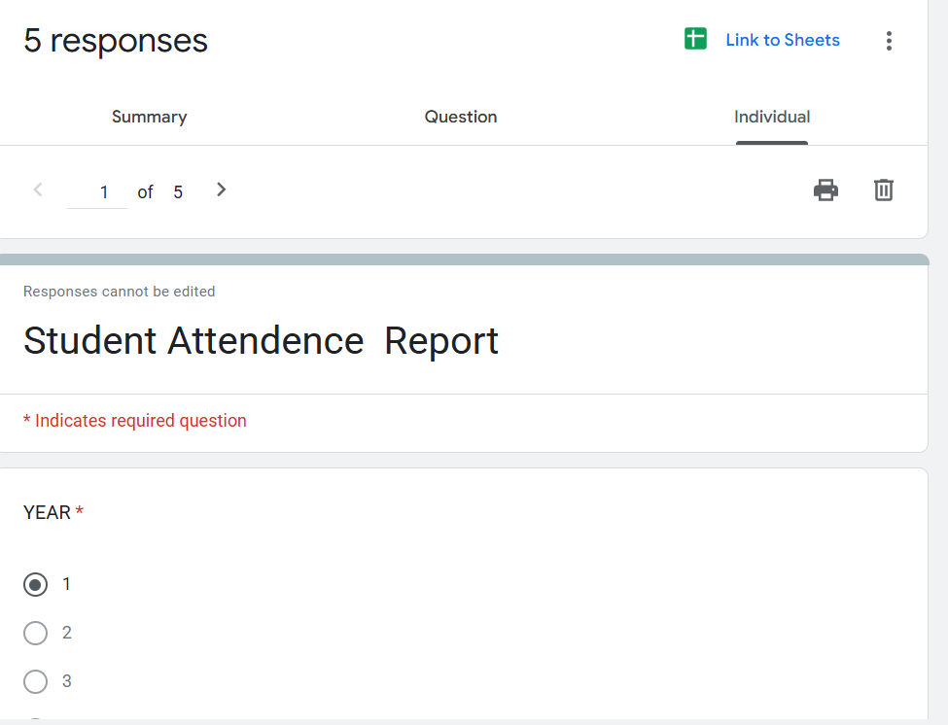
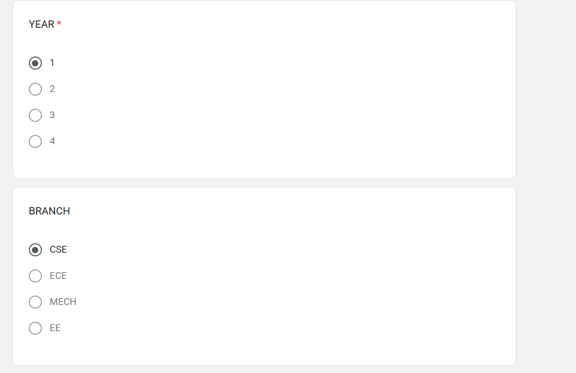
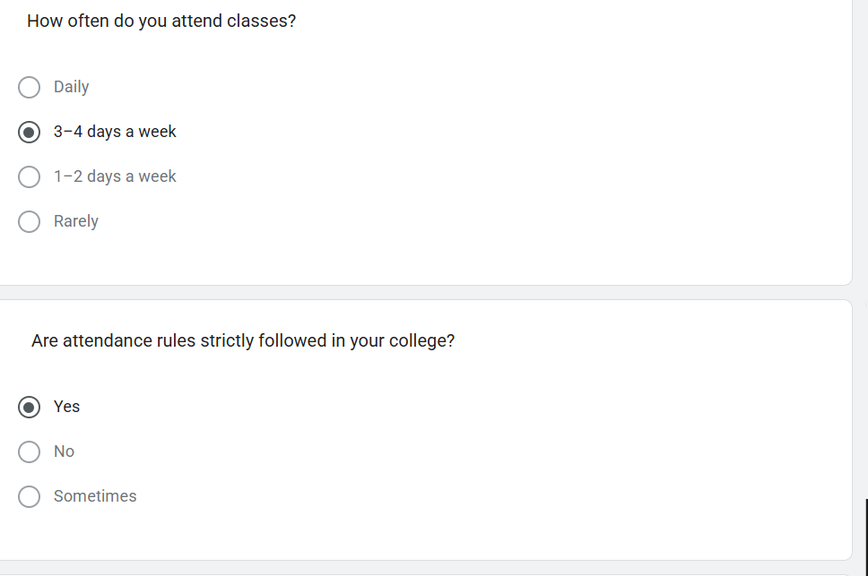
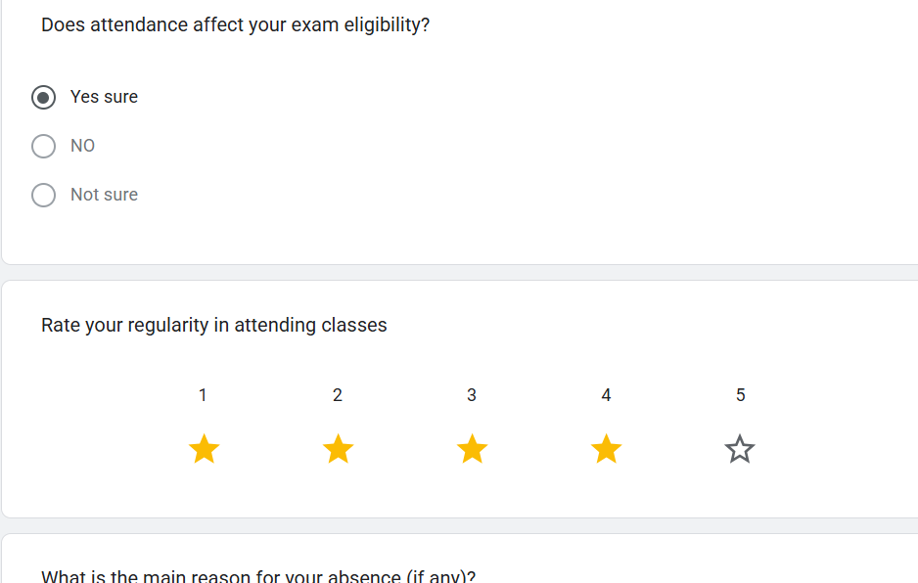
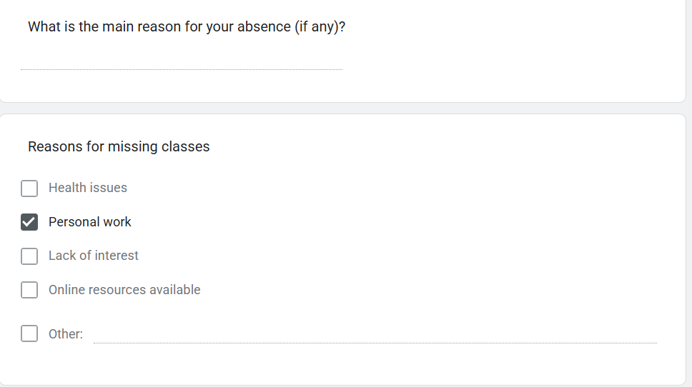

2)
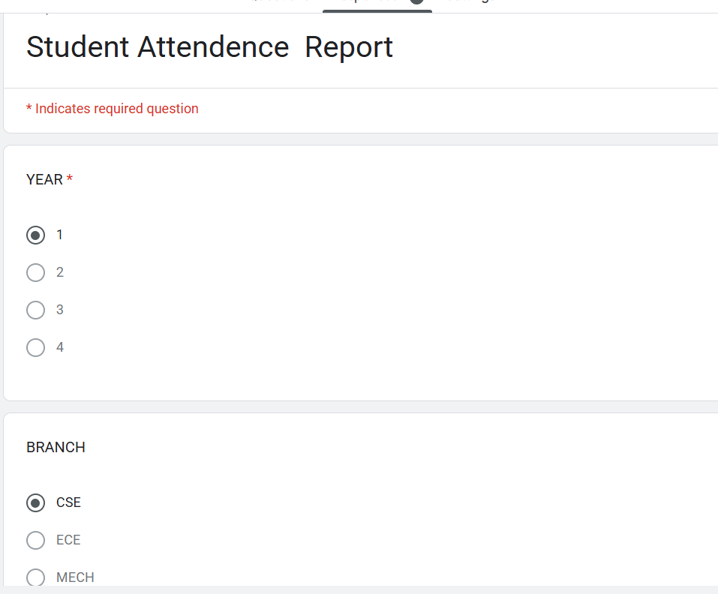
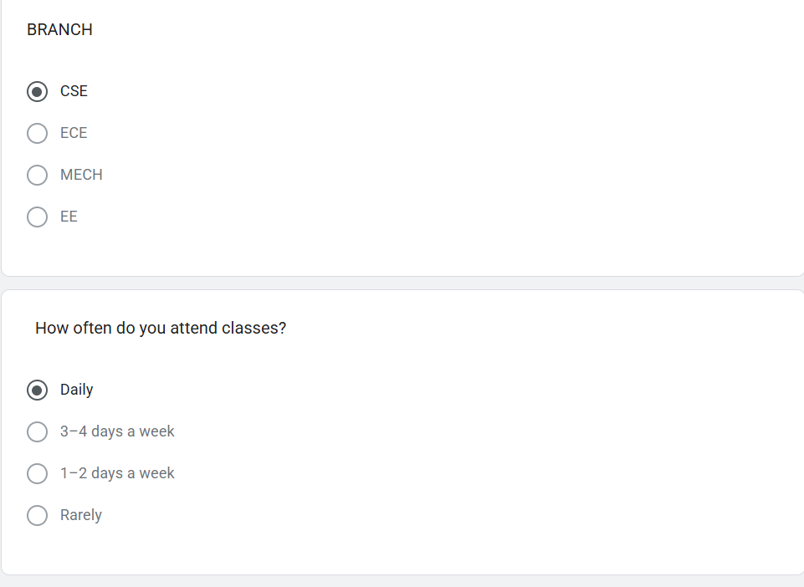
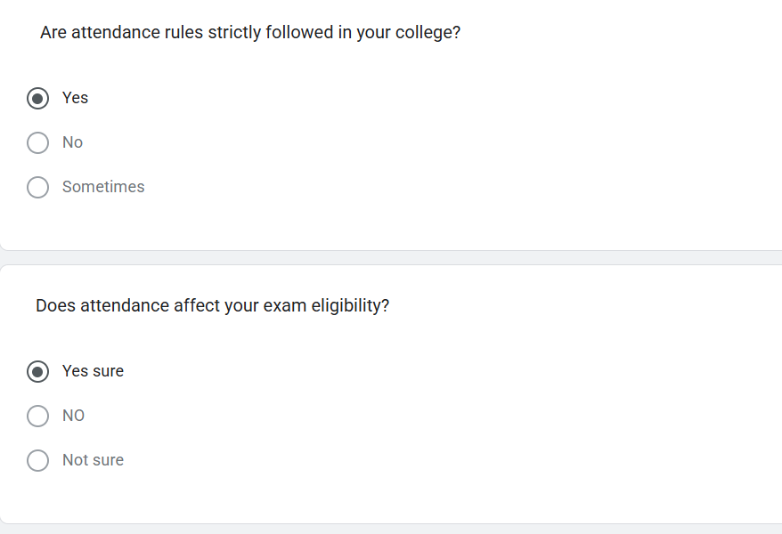
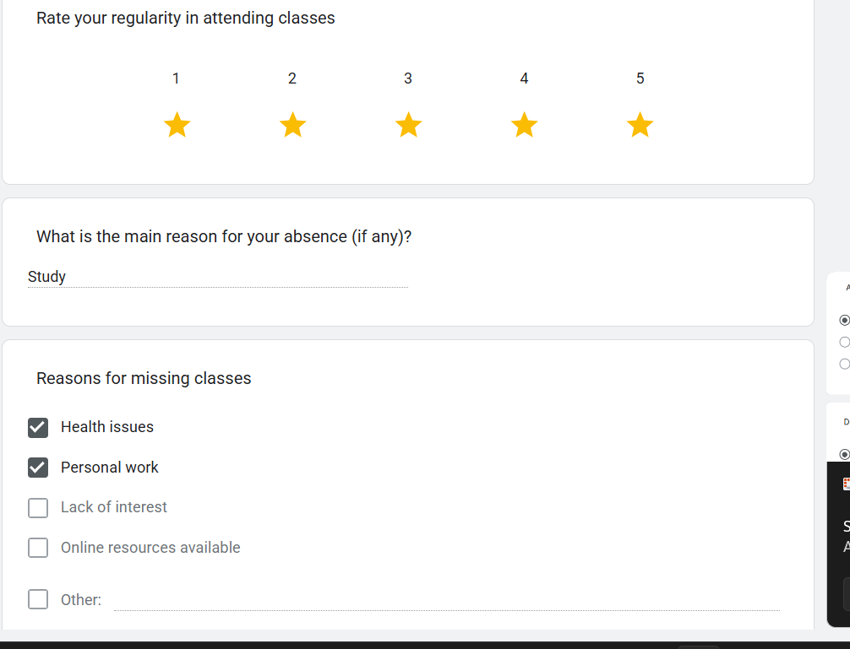
3)
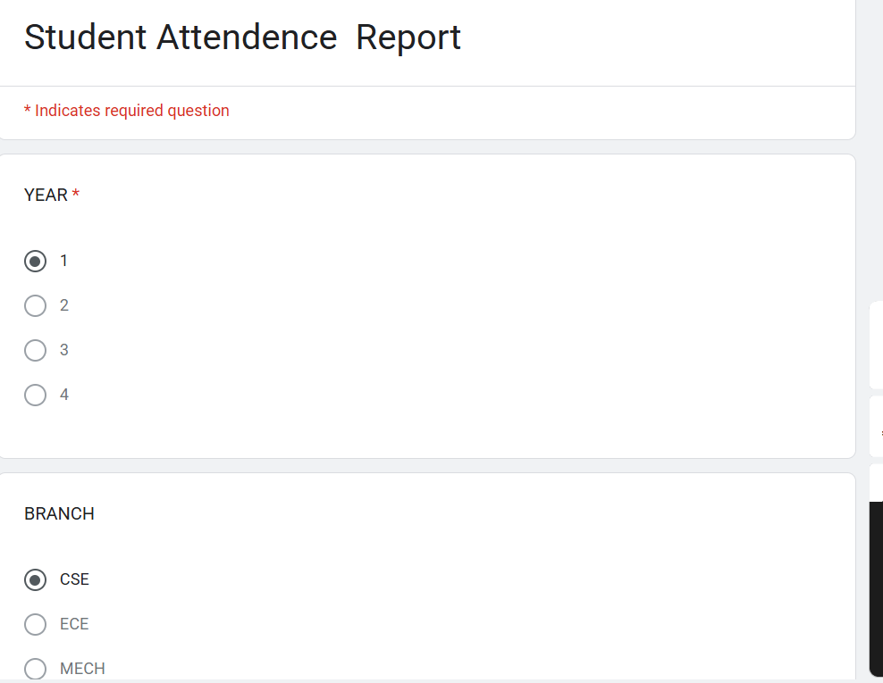
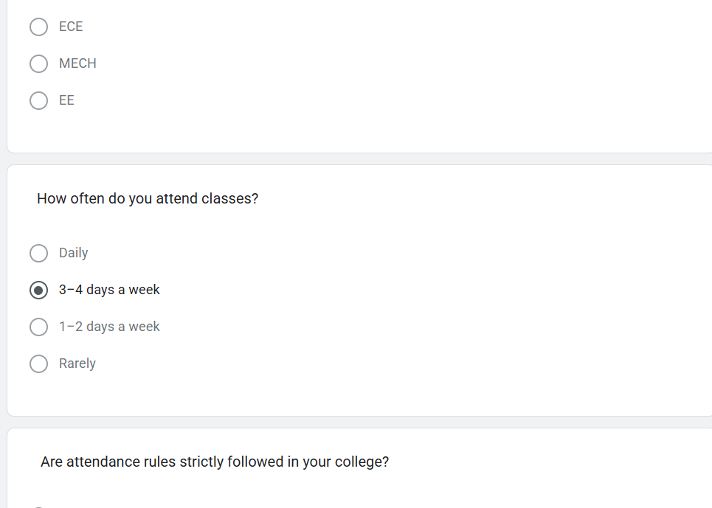

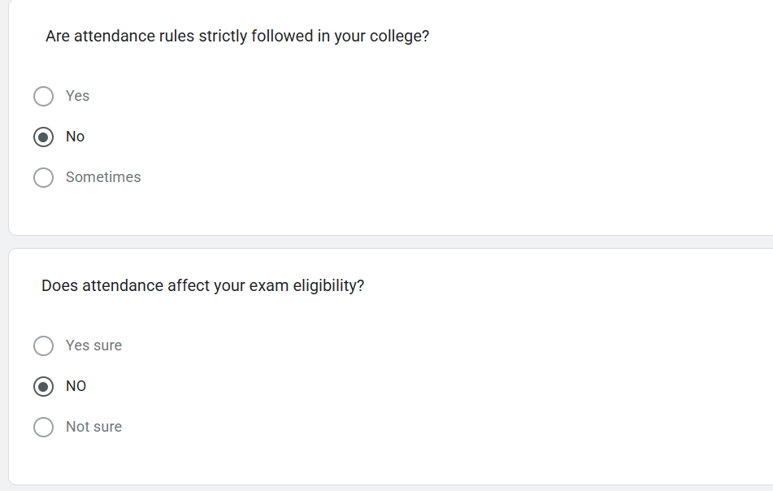
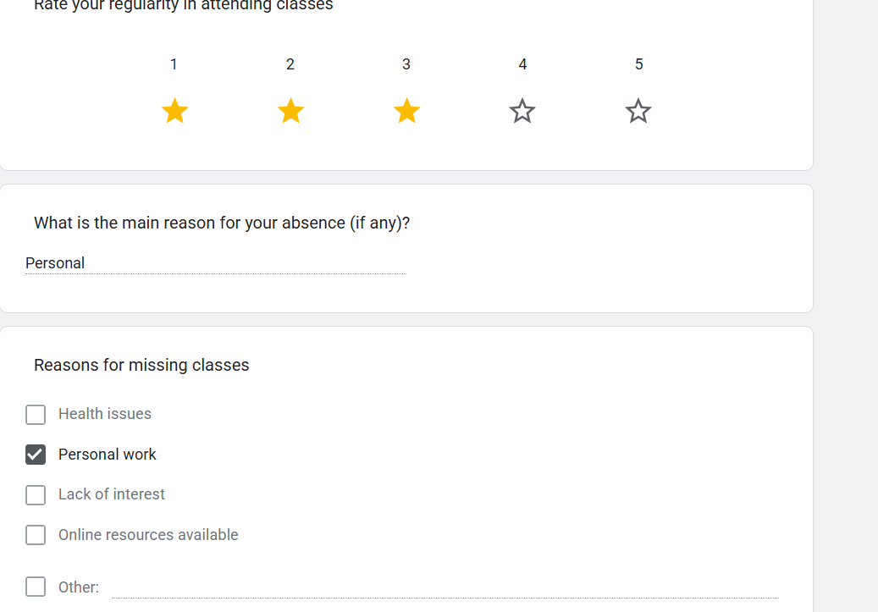
4)
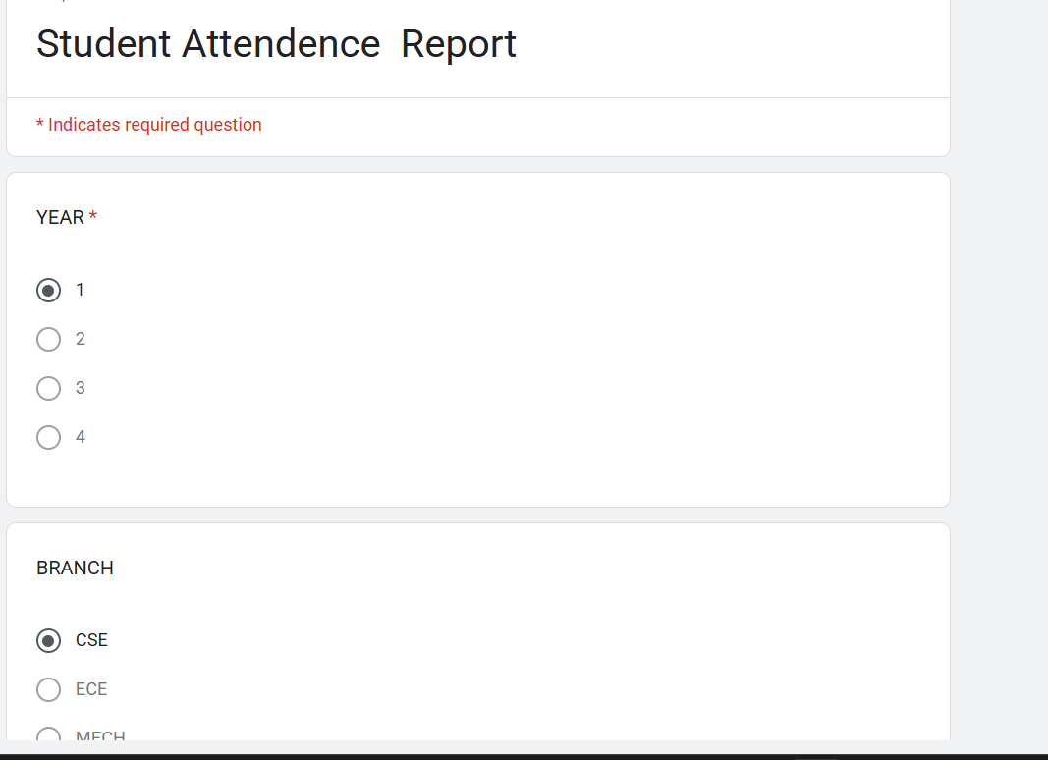
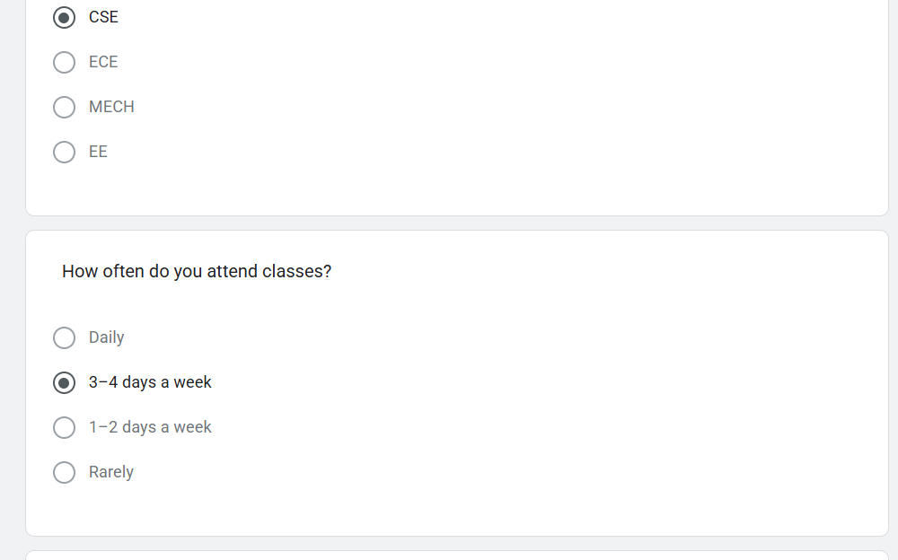
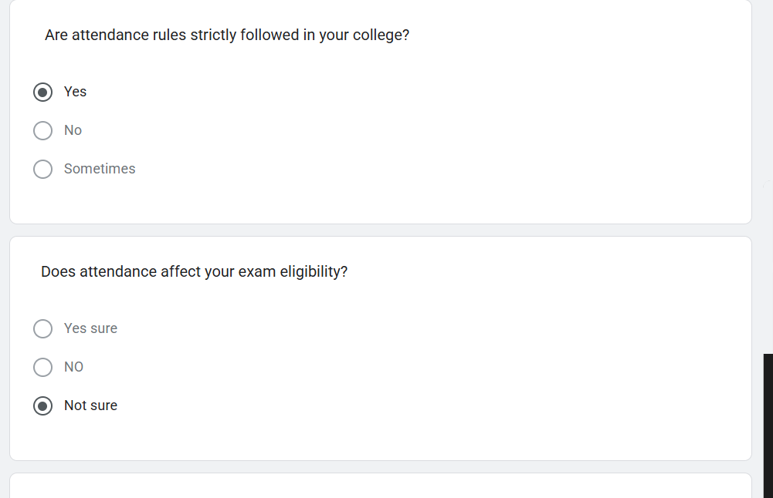
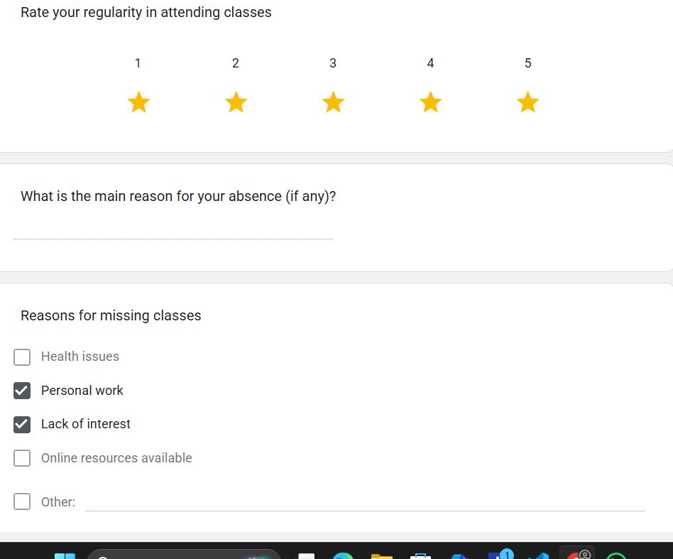
5)
